Project Design Phase-II

Data Flow Diagram & User Stories

|  |  |
| --- | --- |
| Date | 03-11 2022 |
| Team ID | PNT2022TMID37921 |
| Project Name | Project – Global Sales Data Analytics |
| Maximum Marks | 4 Marks |

# Data Flow Diagrams:

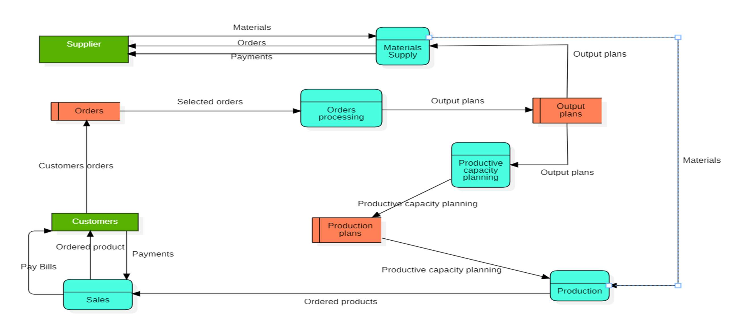A Data Flow Diagram (DFD) is a traditional visual representation of the information flows within a system. A neat and clear DFD can depict the right amount of the system requirement graphically. It shows how data enters and leaves the system, what changes the information, and where data is stored.

# Data Flow Diagrams:

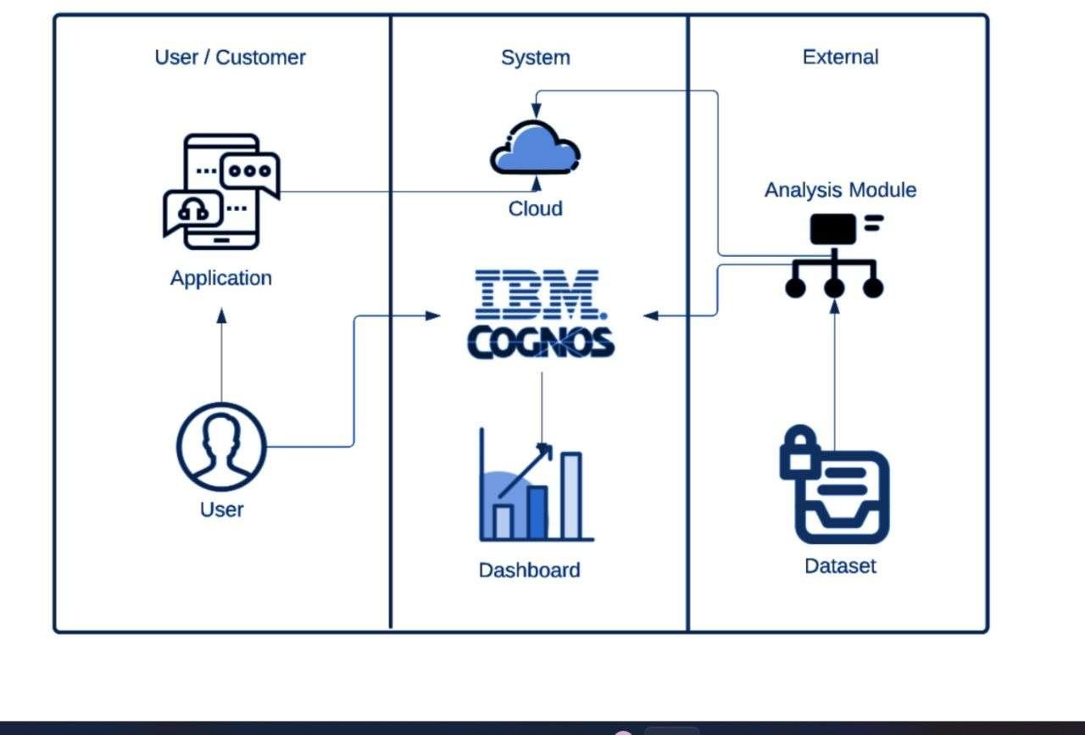

**User Stories**

Use the below template to list all the user stories for the product.

|  |  |  |  |  |  |  |
| --- | --- | --- | --- | --- | --- | --- |
| **User Type** | **Functional Requirement (Epic)** | **User Story Number** | **User Story / Task** | **Acceptance criteria** | **Priority** | **Release** |
| Customer (Mobile user) | Registration | USN-1 | As a user, I can register for the application by  entering my email, password, and confirming my password. | I can access my account / dashboard | High | Sprint-1 |
|  |  | USN-2 | As a user, I will receive confirmation email once I have registered for the application | I can receive confirmation email & click confirm | High | Sprint-1 |
|  | Login | USN-3 | As a user, I can log into the application by entering email & password |  | High | Sprint-1 |
|  | Dashboard | USN-4 | As a user, I can create the visualization by using the dashboard in the application. |  | High | Sprint-3 |

|  |  |  |  |  |  |  |
| --- | --- | --- | --- | --- | --- | --- |
| **User Type** | **Functional Requirement**  **(Epic)** | **User Story Number** | **User Story / Task** | **Acceptance criteria** | **Priority** | **Release** |
| Customer (Web user) | Login | USN-1 | As a user, I can register for the application by entering my email. Password and confirming  my password. | I can access my account and dashboard | High | Sprint-1 |
| Administrator | Mail | USN-1 | It can be used by easily access and responsible. | I can access by easily through application. | High | Sprint-1 |